PL/SQL Solutions

**Candidate Name:** Rohit Tudu  
**Superset ID:** 6393839

**Exercise 1: Control Structures**

**Scenario 1:** The bank wants to apply a discount to loan interest rates for customers above 60 years old.

**Question:** Write a PL/SQL block that loops through all customers, checks their age, and if they are above 60, apply a 1% discount to their current loan interest rates.

**Solution Script:**

**BEGIN**

**FOR record IN (**

**SELECT L.LoanID**

**FROM Customers C**

**JOIN Loans L ON C.CustomerID = L.CustomerID**

**WHERE MONTHS_BETWEEN(SYSDATE, C.DOB) / 12 > 60**

**FOR UPDATE**

**) LOOP**

**UPDATE Loans**

**SET InterestRate = InterestRate - (InterestRate * 0.01)**

**WHERE LoanID = record.LoanID;**

**END LOOP;**

**COMMIT;**

**DBMS_OUTPUT.PUT_LINE('1% interest discount applied to customers above 60!');**

**END;**

**Output:**

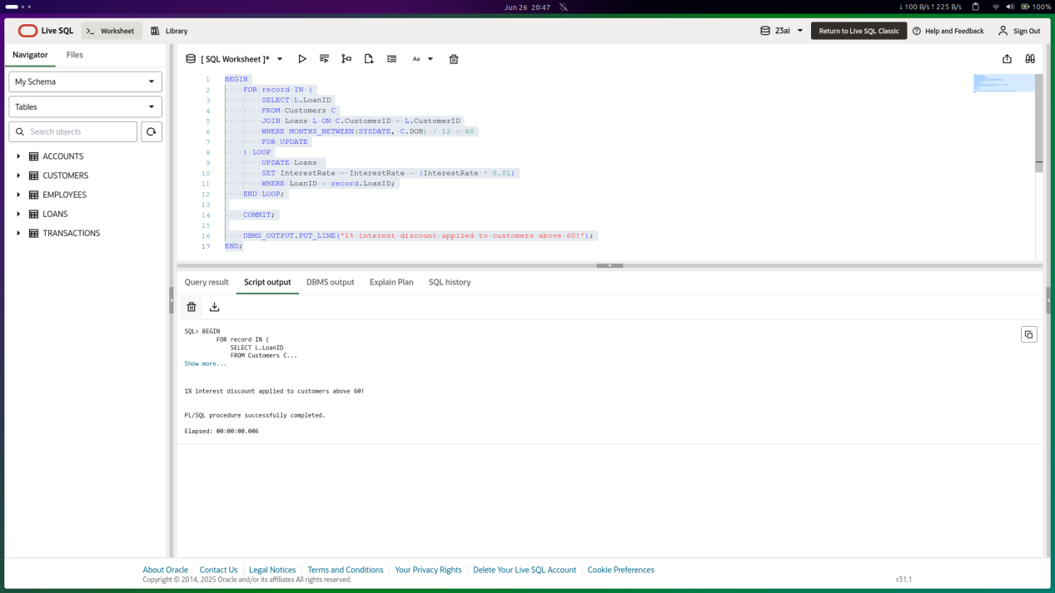

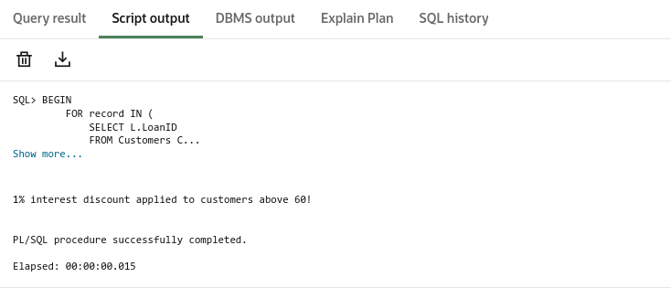

**Scenario 2:** A customer can be promoted to VIP status based on their balance.

**Question:** Write a PL/SQL block that iterates through all customers and sets a flag IsVIP to TRUE for those with a balance over $10,000.

**SOLUTION SCRIPT**

**ALTER TABLE CUSTOMERS**

**ADD ISVIP VARCHAR2(5) DEFAULT 'FALSE';**

**BEGIN**

**FOR RES IN (**

**SELECT CUSTOMERID, BALANCE FROM CUSTOMERS**

**) LOOP**

**IF RES.BALANCE > 10000 THEN**

**UPDATE CUSTOMERS**

**SET ISVIP = 'TRUE'**

**WHERE CUSTOMERID = RES.CUSTOMERID;**

**END IF;**

**END LOOP;**

**COMMIT;**

**END;**

**OUTPUT**

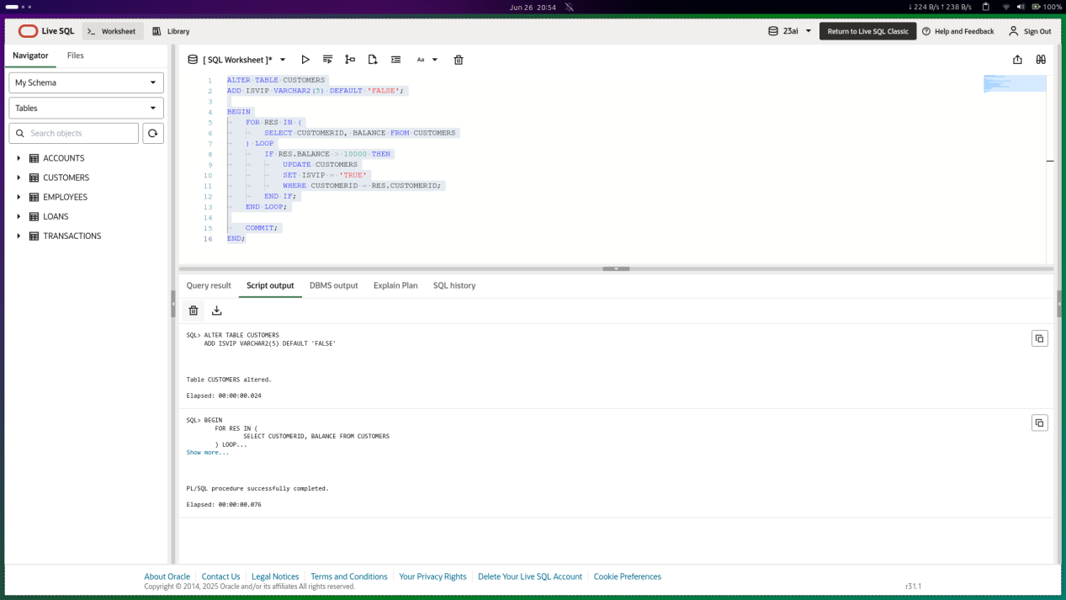

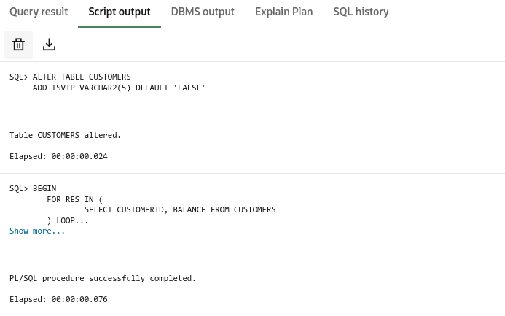

**Scenario 3:** The bank wants to send reminders to customers whose loans are due within the next 30 days.

**Question:** Write a PL/SQL block that fetches all loans due in the next 30 days and prints a reminder message for each customer.

**SOLUTION SCRIPT**

**BEGIN**

**FOR res IN (**

**SELECT C.NAME, C.CUSTOMERID, L.LOANID, L.ENDDATE**

**FROM LOANS L**

**JOIN CUSTOMERS C ON L.CUSTOMERID = C.CUSTOMERID**

**WHERE L.ENDDATE BETWEEN SYSDATE AND SYSDATE + 30**

**) LOOP**

**DBMS_OUTPUT.PUT_LINE(**

**'Reminder: Customer ' || res.NAME ||**

**' (ID: ' || res.CUSTOMERID || ') has a loan due on ' ||**

**TO_CHAR(res.ENDDATE, 'YYYY-MM-DD')**

**);**

**END LOOP;**

**END;**

**/**

**OUTPUT**

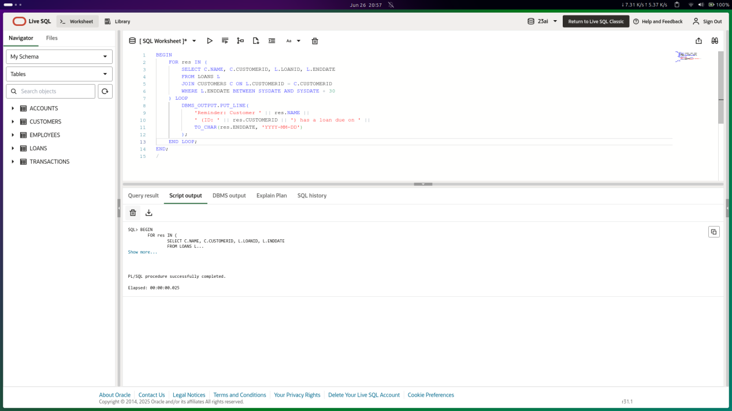

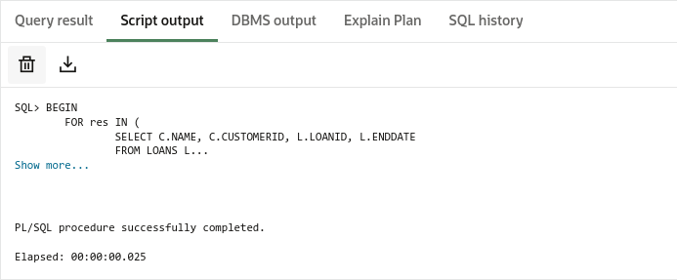

**Exercise 3: Stored Procedures**

**Scenario 1:** The bank needs to process monthly interest for all savings accounts.

**Question:** Write a stored procedure **ProcessMonthlyInterest** that calculates and updates the balance of all savings accounts by applying an interest rate of 1% to the current balance.

**SOLUTION SCRIPT**

**CREATE OR REPLACE PROCEDURE ProcessMonthlyInterest IS**

**BEGIN**

**FOR RECORD IN (**

**SELECT CUSTOMERID FROM CUSTOMERS**

**FOR UPDATE**

**) LOOP**

**UPDATE CUSTOMERS**

**SET BALANCE = BALANCE + BALANCE * 0.01**

**WHERE CUSTOMERID = RECORD.CUSTOMERID;**

**END LOOP;**

**COMMIT;**

**END;**

**/**

**-- or**

**CREATE OR REPLACE PROCEDURE ProcessMonthlyInterest IS**

**BEGIN**

**UPDATE CUSTOMERS**

**SET BALANCE = BALANCE + BALANCE * 0.01;**

**COMMIT;**

**END;**

**/**

**BEGIN**

**ProcessMonthlyInterest;**

**END;**

**OUTPUT**

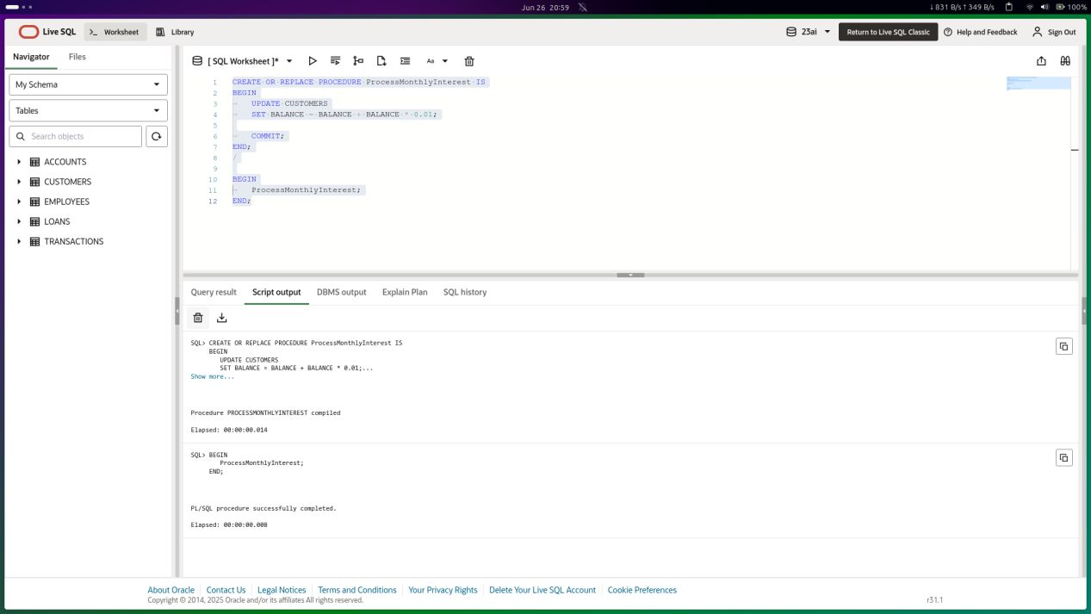

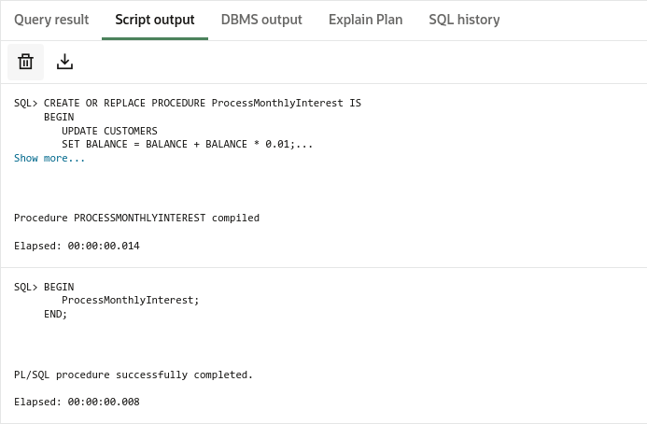

**Scenario 2:** The bank wants to implement a bonus scheme for employees based on their performance.

**Question:** Write a stored procedure **UpdateEmployeeBonus** that updates the salary of employees in a given department by adding a bonus percentage passed as a parameter.

**SOLUTION SCRIPT**

**CREATE OR REPLACE PROCEDURE UpdateEmployeeBonus (**

**dept_name IN VARCHAR2,**

**bonus_percent IN NUMBER**

**) IS**

**BEGIN**

**FOR RECORD IN (**

**SELECT EMPLOYEEID FROM EMPLOYEES**

**WHERE DEPARTMENT = dept_name**

**FOR UPDATE**

**) LOOP**

**UPDATE EMPLOYEES**

**SET SALARY = SALARY + SALARY * (bonus_percent/100)**

**WHERE EMPLOYEEID = RECORD.EMPLOYEEID;**

**END LOOP;**

**DBMS_OUTPUT.PUT_LINE('Bonus added to ' || dept_name || ' Employees!');**

**END;**

**/**

**BEGIN**

**UpdateEmployeeBonus(dept_name => 'IT', bonus_percent => 10);**

**END;**

**OUTPUT**

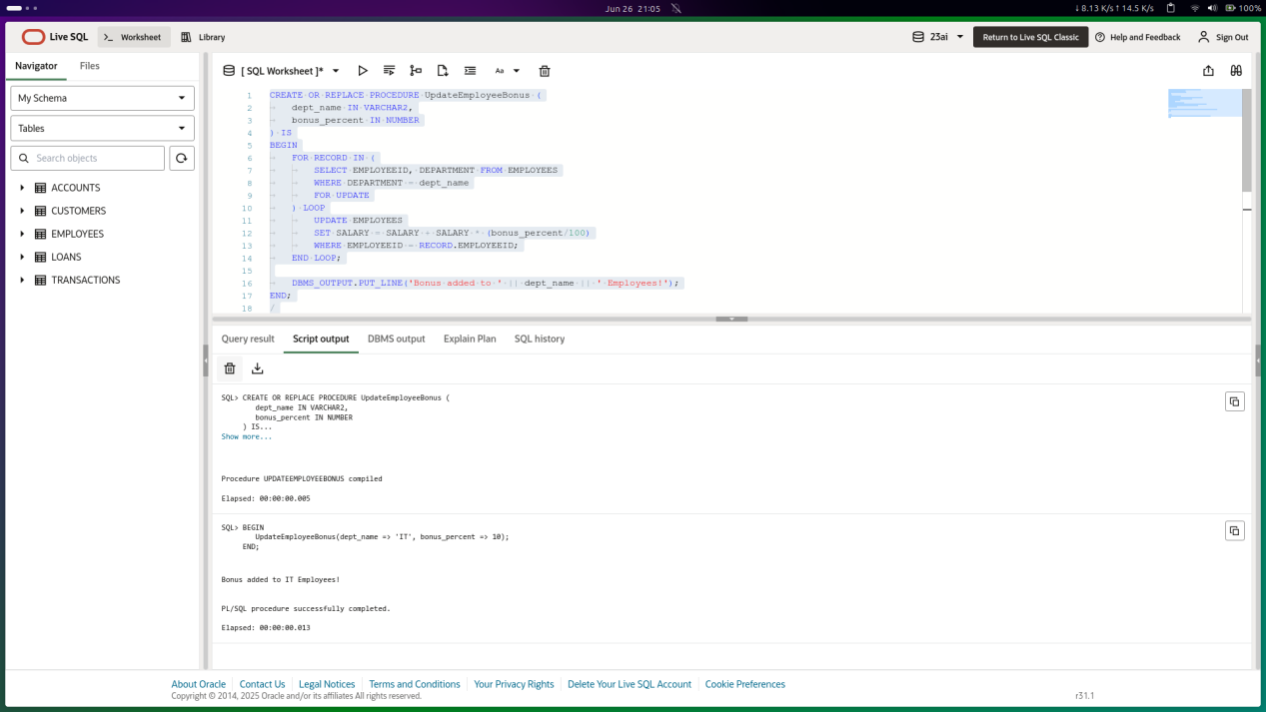

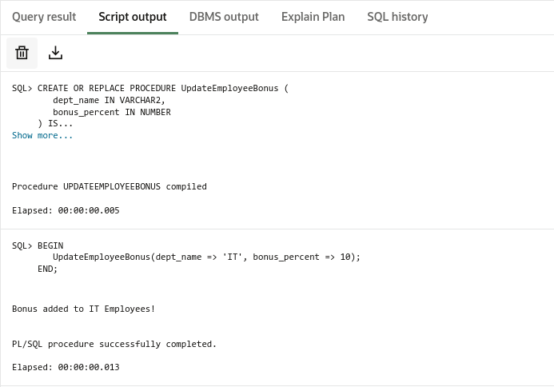

**Scenario 3:** Customers should be able to transfer funds between their accounts.

**Question:** Write a stored procedure **TransferFunds** that transfers a specified amount from one account to another, checking that the source account has sufficient balance before making the transfer.

**SOLUTION SCRIPT**

**CREATE OR REPLACE PROCEDURE UpdateEmployeeBonus (**

**dept_name IN VARCHAR2,**

**bonus_percent IN NUMBER**

**) IS**

**BEGIN**

**FOR RECORD IN (**

**SELECT EMPLOYEEID FROM EMPLOYEES**

**WHERE DEPARTMENT = dept_name**

**FOR UPDATE**

**) LOOP**

**UPDATE EMPLOYEES**

**SET SALARY = SALARY + SALARY * (bonus_percent/100)**

**WHERE EMPLOYEEID = RECORD.EMPLOYEEID;**

**END LOOP;**

**DBMS_OUTPUT.PUT_LINE('Bonus added to ' || dept_name || ' Employees!');**

**END;**

**/**

**BEGIN**

**UpdateEmployeeBonus(dept_name => 'IT', bonus_percent => 10);**

**END;**

**OUTPUT**

